LAB2:

Parallel VHDL

**Introduction:**

In this lab, I have designed a single bit and four bit multiplexer by taking four inputs (a, b, c, d) and an output (x) with a select bit (s) through which we can select an output.

In a single bit multiplexer, we will take select (s) as two bit input and both input and output would be single bit.

In four bit multiplexer, we will take four bit input and output whereas, select bit will remain same.

For an output waveform, I have taken input (a) as clock starting from 0, input (b) as a constant of logic 0, similarly input (c) as a constant with logic 1, input (d) as a clock starting from 1 and a select bit (s) as a two bit counter.

**Single bit Multiplexer:**

**RTL VIEW:**

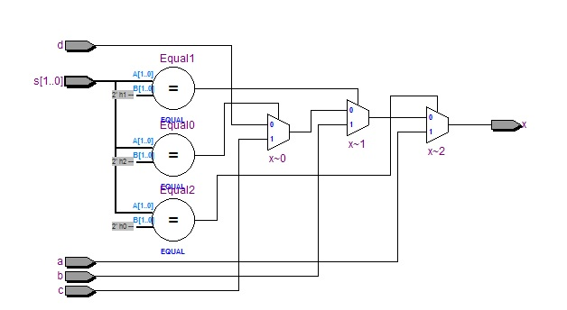

**Waveform:**

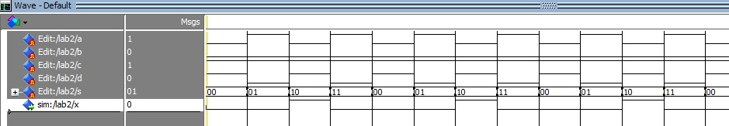

**CODE:**

LIBRARY IEEE;

USE IEEE.std_logic_1164.all;

Entity lab2 IS

PORT (a, b, c, d : IN std_logic;

s : IN std_logic_vector (1 downto 0);

x : OUT std_logic

);

END lab2;

ARCHITECTURE mux OF lab2 IS

BEGIN

x <= a when s="00" ELSE

b when s="01" ELSE

c when s="10" ELSE

d when s="11" ELSE

'X';

END mux;

**Four bit Multiplexer:**

**RTL VIEW:**

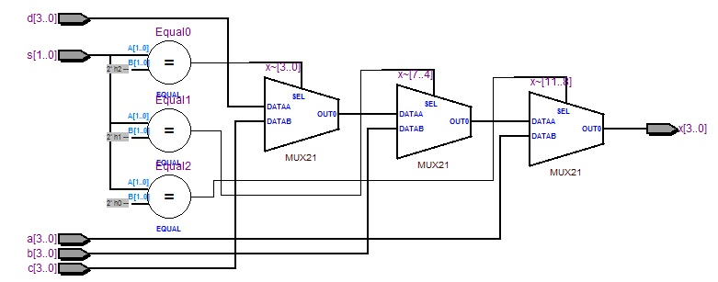

**WAVEFORM:**

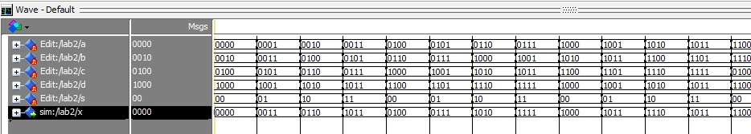

**CODE:**

Library ieee;

Use ieee.std_logic_1164.All;

Entity lab2 is

port

(a,b,c,d: in std_logic_vector(3 downto 0);

s : in std_logic_vector(1 downto 0);

x : out std_logic_vector(3 downto 0)

);

End Entity;

Architecture mux4 of lab2 is

begin

x <= a when s= "00" else

b when s= "01" else

c when s= "10" else

d when s= "11" else

(others=>'X');

End mux4;

**Conclusion:**

We can easily design a multiplexer in VHDL and verify its result through simulation.